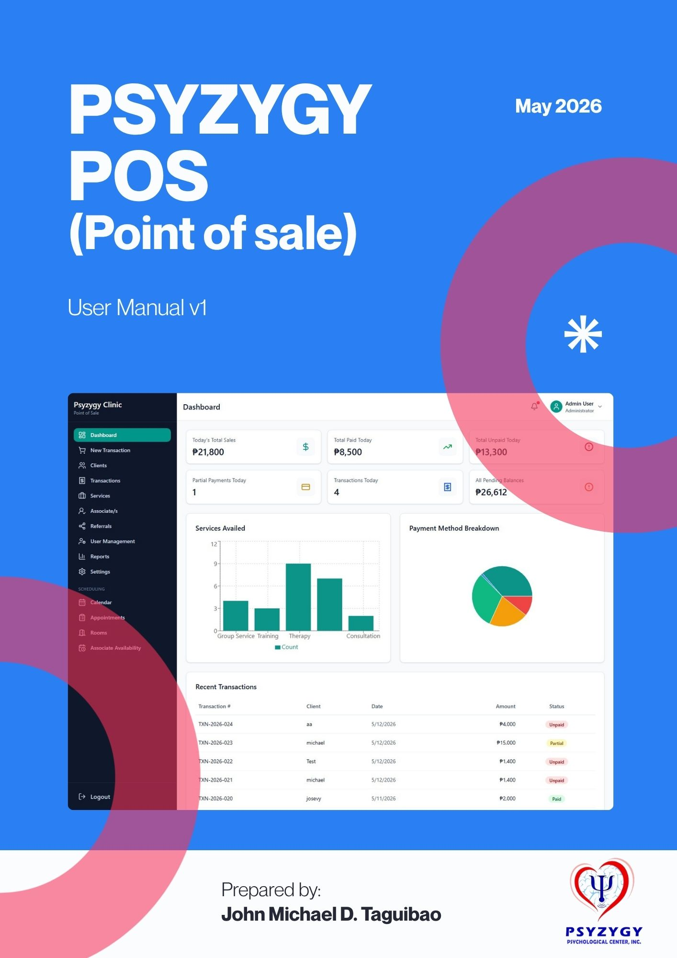
Front desk guide

Psyzygy Clinic POS User Manual
Front desk guide for Psyzygy Psychological Center.

This manual explains the daily workflows for logging in, creating POS transactions, scheduling appointments, collecting payments, printing receipts, and managing scheduling records.

Table of Contents
1. Login
2. Dashboard
3. Client Selection
4. POS Transaction Workflow
5. Transaction History and Receipt Printing
6. Scheduling Appointments
7. Appointment Calendar
8. Rooms Management
9. Associate Availability
10. Client Management
11. Services Management
12. Associate/s Management
13. Referrals
14. Reports
15. Settings
16. Daily Front Desk Checklist

1. Login
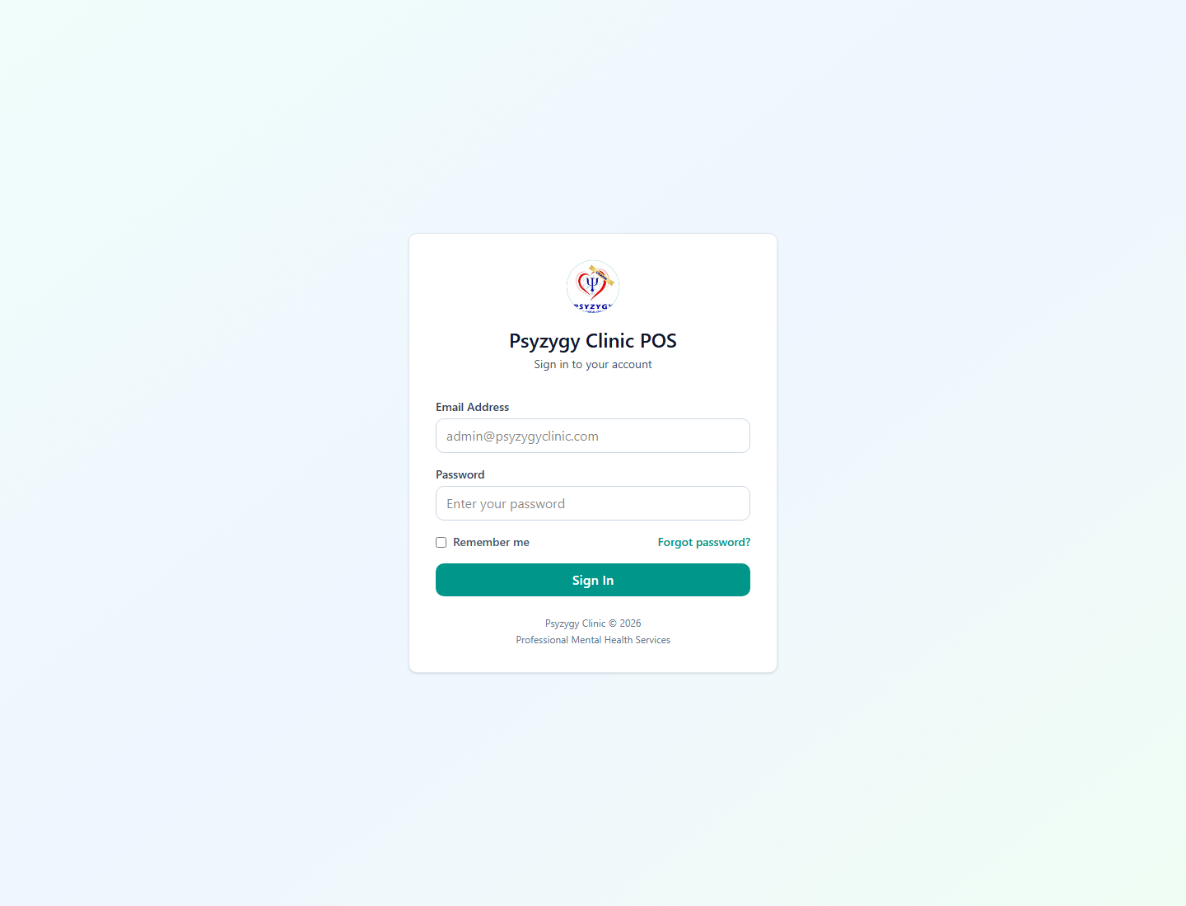
Login screen
Use the login page to access the system.
Steps:
1. Enter your assigned email address.
2. Enter your password.
3. Click Sign In.
4. If you forgot your password, enter your email first, then click Forgot password?.
Notes:
? Use only your assigned account.
? Do not share passwords between staff members.
? If login fails, confirm the spelling of the email address and ask an administrator to check whether the user is active.

2. Dashboard
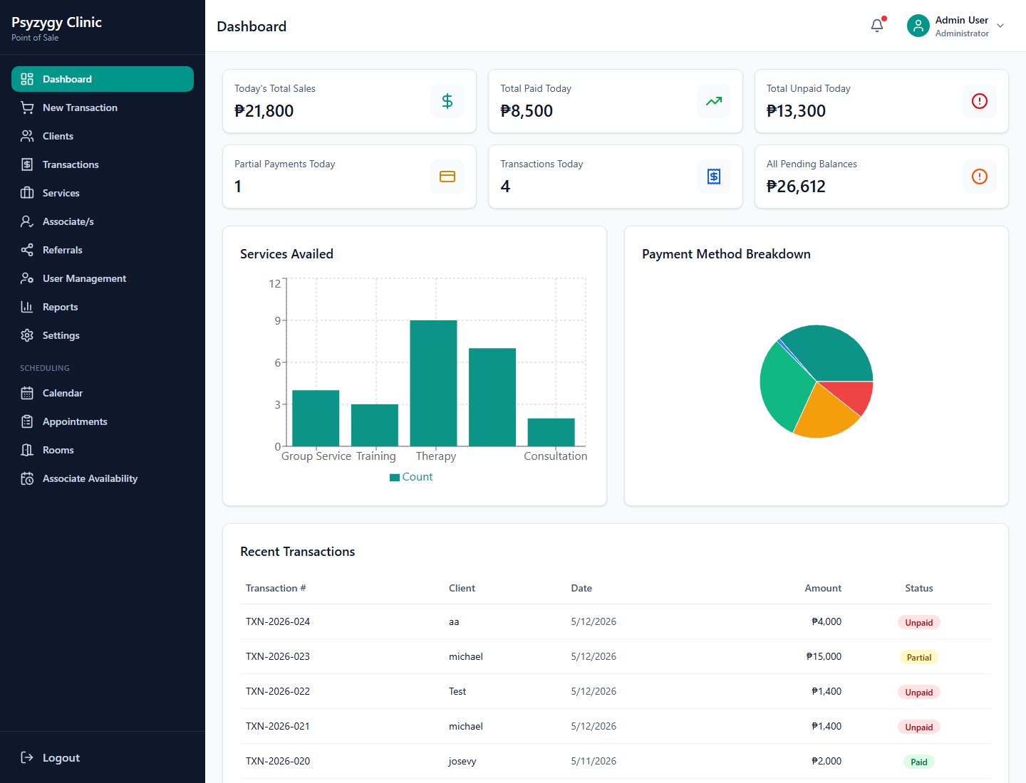
Dashboard
The dashboard is the first page after login. It gives staff a quick view of clinic activity and POS performance.
Use this page to:
1. Check recent sales and payment activity.
2. Review totals and quick metrics.
3. Navigate to POS, transactions, reports, or scheduling from the sidebar.

3. Client Selection
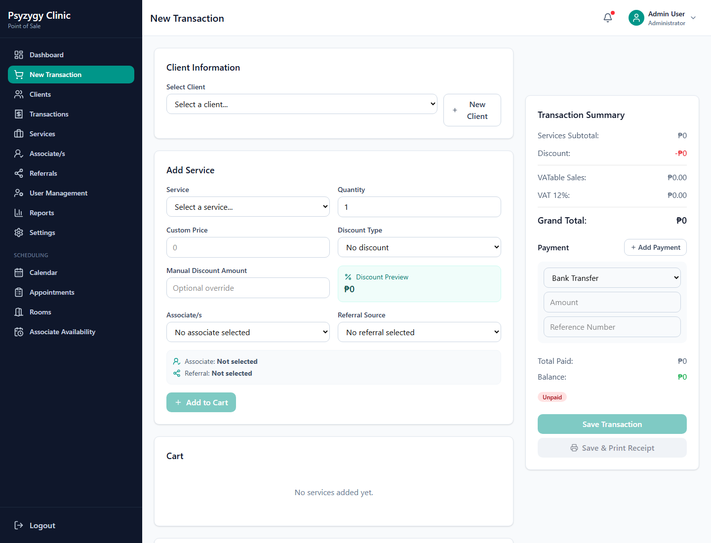
Client selection in POS
Client selection happens at the start of a POS transaction.
Steps:
1. Click New Transaction in the sidebar.
2. Under Client Information, open Select Client.
3. Choose the client receiving the service.
4. Review the displayed contact, age, and sex information.
5. If the client is new, click New Client and enter the client profile before continuing.
Tip:
? Always select the correct client before adding services. Receipts and transaction history are linked to the selected client.

4. POS Transaction Workflow
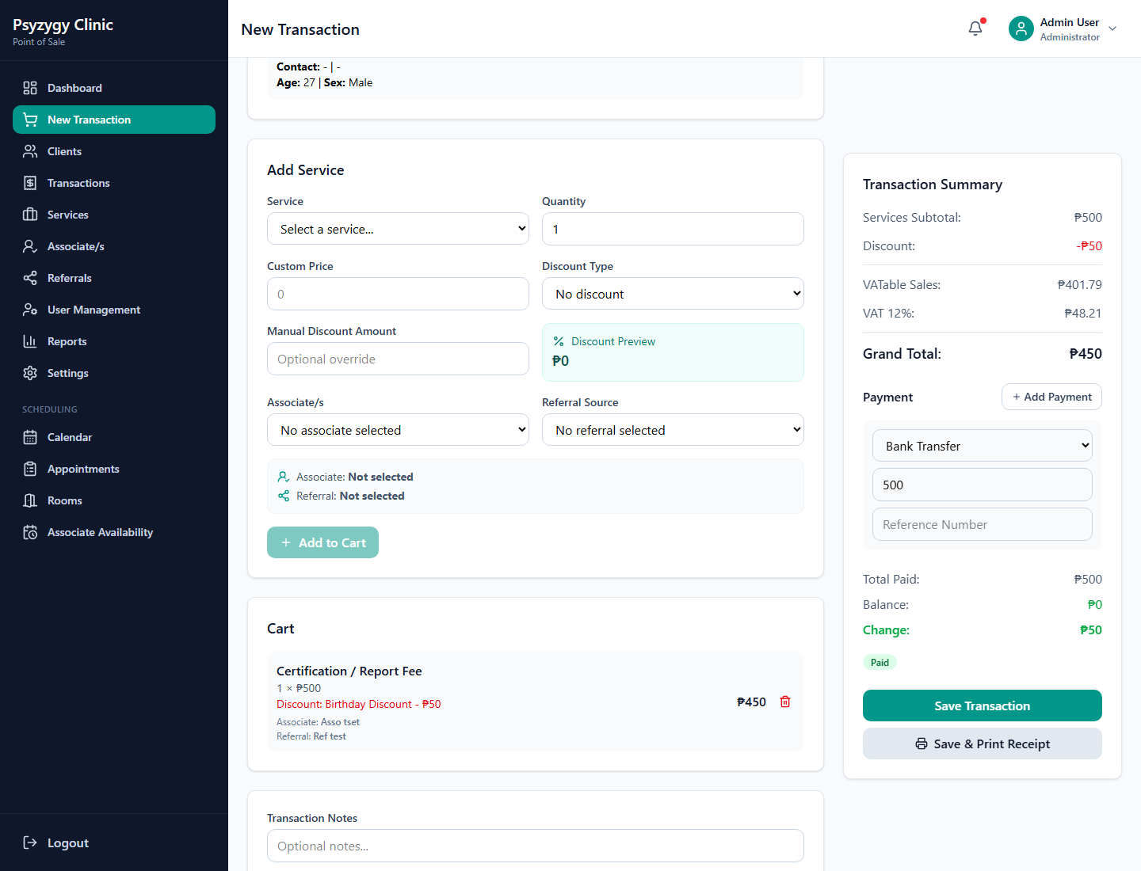
POS service, discount, tax, and payment workflow
Use New Transaction when collecting payment for services.

Add Service
Steps:
1. In Add Service, choose the service from the Service dropdown.
2. Confirm the Quantity.
3. Enter a Custom Price only when the price should differ from the default service price.
4. Select a Discount Type if applicable.
5. Enter a Manual Discount Amount only when an override is approved.
6. Click Add to Cart.
The cart shows:
? Service name
? Quantity and unit price
? Discount applied
? Associate/s
? Referral source
? Line total

Select Associate
Steps:
1. In the Associate/s dropdown, select the associate assigned to the service.
2. Confirm the selected associate appears in the preview area.
3. Add the service to the cart.
Notes:
? Use the associate who actually handled or will handle the service.
? This helps reports and receipts show the correct service provider.

Select Referral
Steps:
1. In Referral Source, select the referral source when applicable.
2. Confirm the referral appears in the preview area.
3. Add the service to the cart.
Use this when the client or service came from a school, company, doctor, organization, or other referral source.

Apply Discount
Steps:
1. Select the correct discount from Discount Type.
2. If needed, enter a manual amount in Manual Discount Amount.
3. Review Discount Preview before adding the service to the cart.
4. Confirm the discount appears in the cart and transaction summary.
Important:
? Use manual discounts only when authorized.
? Senior Citizen, PWD, and other configured discounts should be selected from the discount dropdown when available.

VAT/Tax Display
The transaction summary automatically displays tax based on the clinic settings.
If VAT is enabled:
1. The system shows VATable Sales.
2. The system shows VAT 12% or the configured VAT rate.
3. The Grand Total reflects the configured inclusive or exclusive tax mode.
If NON-VAT is enabled:
1. The system shows NON-VAT REGISTERED.
2. The system shows VAT-EXEMPT SALE.
3. VAT amount remains zero.
Always review the Grand Total before collecting payment.

Partial and Full Payment
Steps:
1. In the Payment section, choose the payment method.
2. Enter the amount received.
3. For non-cash methods, enter the reference number if available.
4. Review Total Paid, Balance, Change, and the payment status badge.
5. For partial payments, enter only the amount received.
6. For full payments, enter the full grand total.
7. Click Save Transaction or Save & Print Receipt.
Payment statuses:
? Unpaid means no payment was collected.
? Partial means payment was collected but a balance remains.
? Paid means the transaction is fully paid.
? Void means the transaction was voided and should not be collected.

5. Transaction History and Receipt Printing
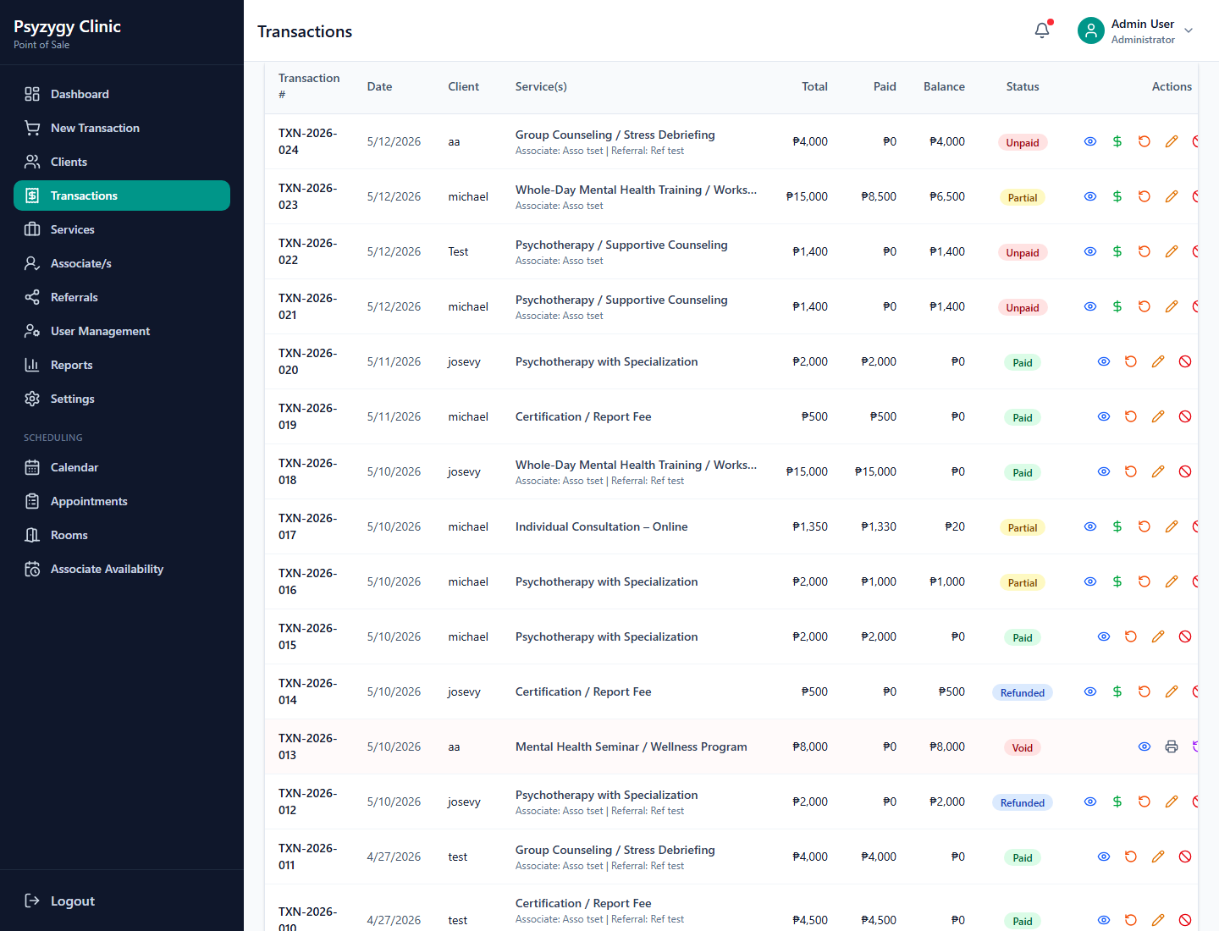
Transaction history
The Transactions page lists saved transactions.
Use this page to:
1. Search or filter transactions.
2. Review payment status.
3. Add payment to unpaid or partial transactions.
4. Print receipts.
5. Void transactions when required.
6. Record refunds when approved.
7. Review audit history.

6. Print Receipt
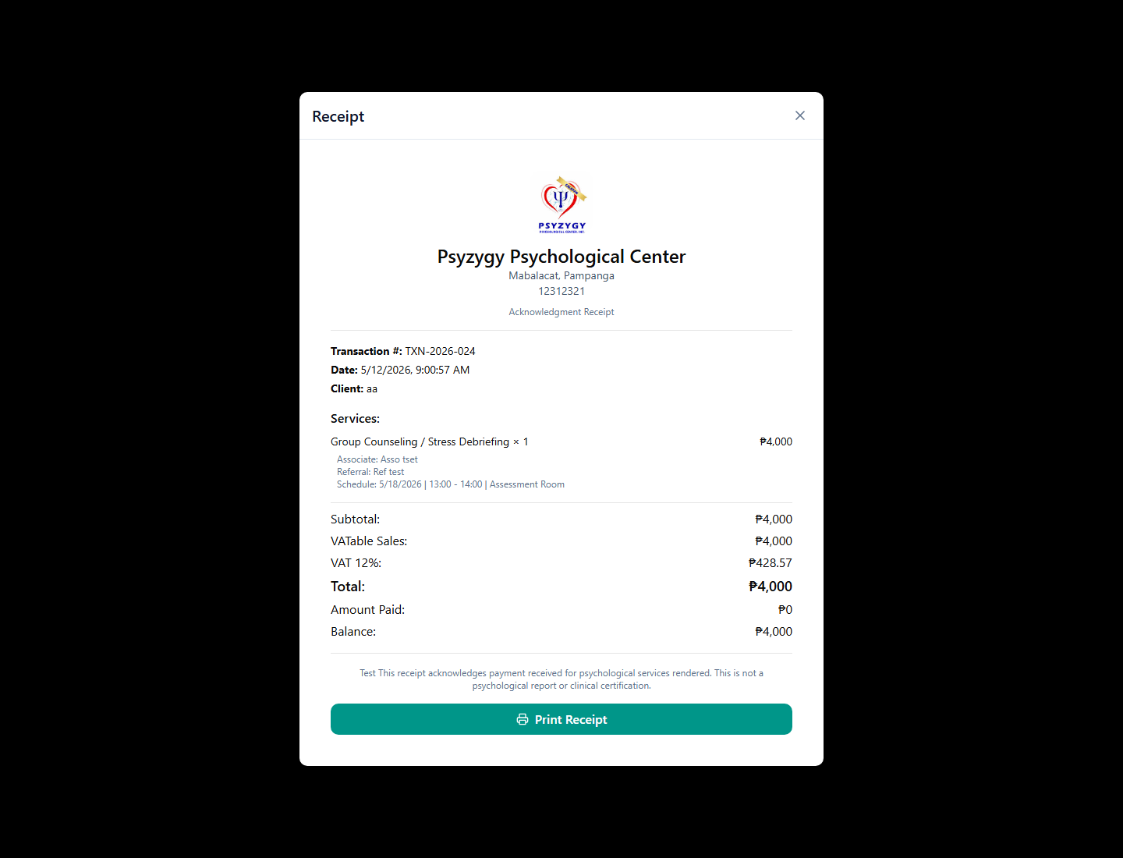
Receipt printing
Steps:
1. Go to Transactions.
2. Find the transaction.
3. Click the print receipt button.
4. Review the receipt details.
5. Click Print Receipt.
Receipt details include:
? Clinic logo and clinic information
? Transaction number and date
? Client name
? Services
? Associate/s
? Referral source
? Schedule, if the service came from an appointment
? VAT or NON-VAT details
? Total, amount paid, and balance
? Receipt footer
For scheduled services, the receipt shows the appointment date, time, and room.
Example:
Schedule: 5/18/2026 | 13:00 - 14:00 | Assessment Room

7. Scheduling Appointments
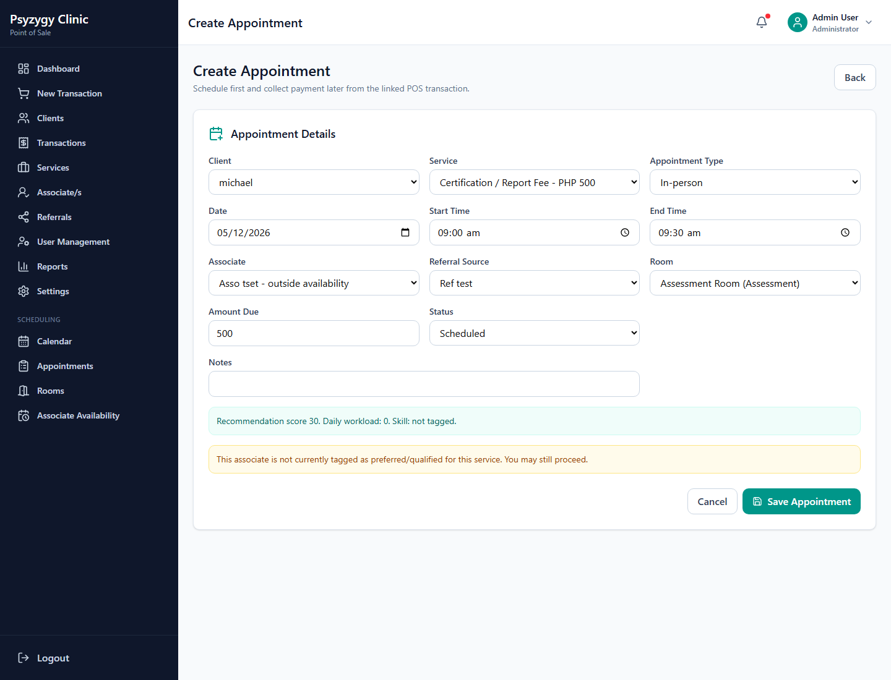
Create appointment
Use scheduling when the clinic needs to book the service first and collect payment later.
Steps:
1. Go to Calendar or Appointments.
2. Click New Appointment.
3. Select the Client.
4. Select the Service.
5. Choose the Appointment Type: In-person, Online, or Hybrid.
6. Select the appointment Date.
7. Enter Start Time and End Time.
8. Select the Associate.
9. Select the Referral Source, if applicable.
10. Select the Room for in-person or hybrid appointments.
11. Confirm the Amount Due.
12. Keep the status as Scheduled unless the appointment is already confirmed.
13. Add notes when needed.
14. Click Save Appointment.
Scheduling checks:
? The associate should be available for the selected date and time.
? The room should not have a conflicting appointment.
? The client should not have another overlapping appointment.
? Inactive services, rooms, or associates should not be used.
If a warning appears, read it before saving. The system may allow staff to continue, but the warning should be reviewed.

Convert Appointment to POS Transaction
Use this when the client is ready to pay for a scheduled appointment.
Steps:
1. Open Appointments or Calendar.
2. Open the appointment details.
3. Click Create POS Transaction.
4. Go to Transactions.
5. Find the created transaction.
6. Click Add Payment when the client pays.
7. Print the receipt after payment is recorded.
The appointment and transaction remain linked. Payment status updates based on collected payment.

8. Appointment Calendar
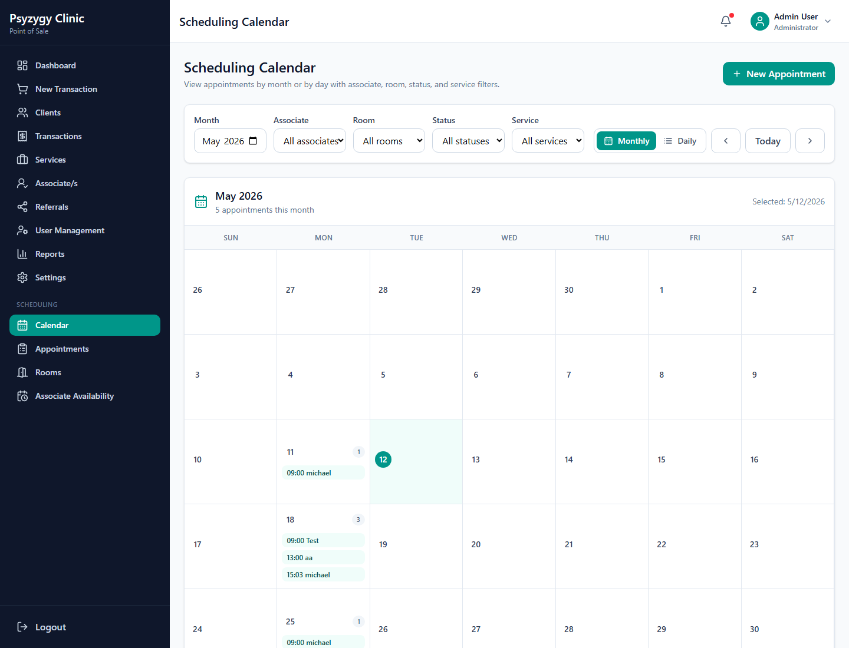
Monthly appointment calendar
The monthly calendar works like a physical clinic calendar.
Use it to:
1. View appointments for the month.
2. Select a specific date.
3. Open appointment details by clicking a scheduled item.
4. Filter by associate, room, status, or service.
5. Create a new appointment.
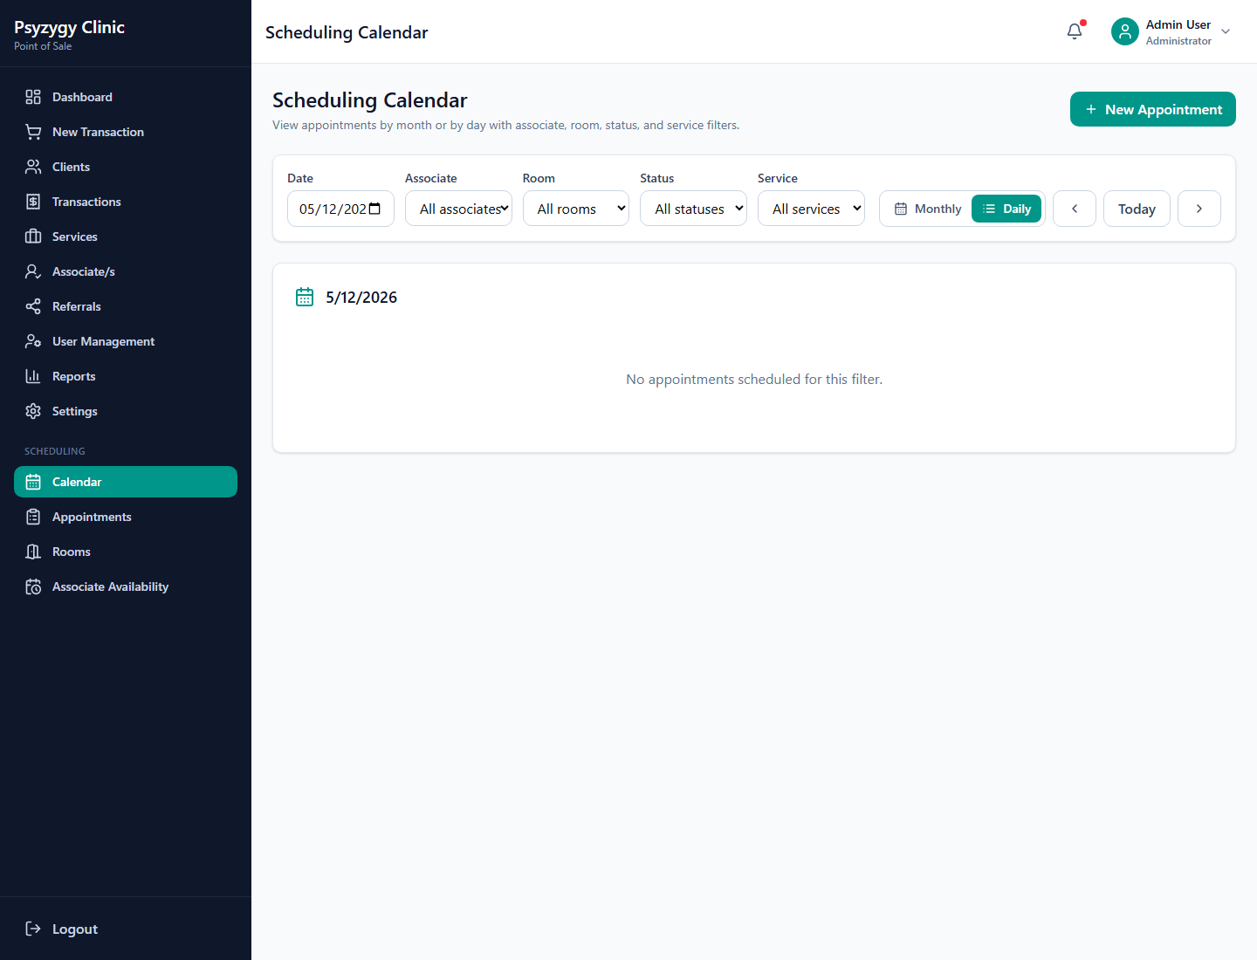
Daily appointment calendar
The daily view shows appointments for one date.
Use it to:
1. Review the day schedule.
2. Check appointment status.
3. Check payment status.
4. Open appointment details.
5. Move to previous or next day.
Tip:
? When opening appointment details from the calendar, the Back button returns to the same calendar view.

9. Rooms Management
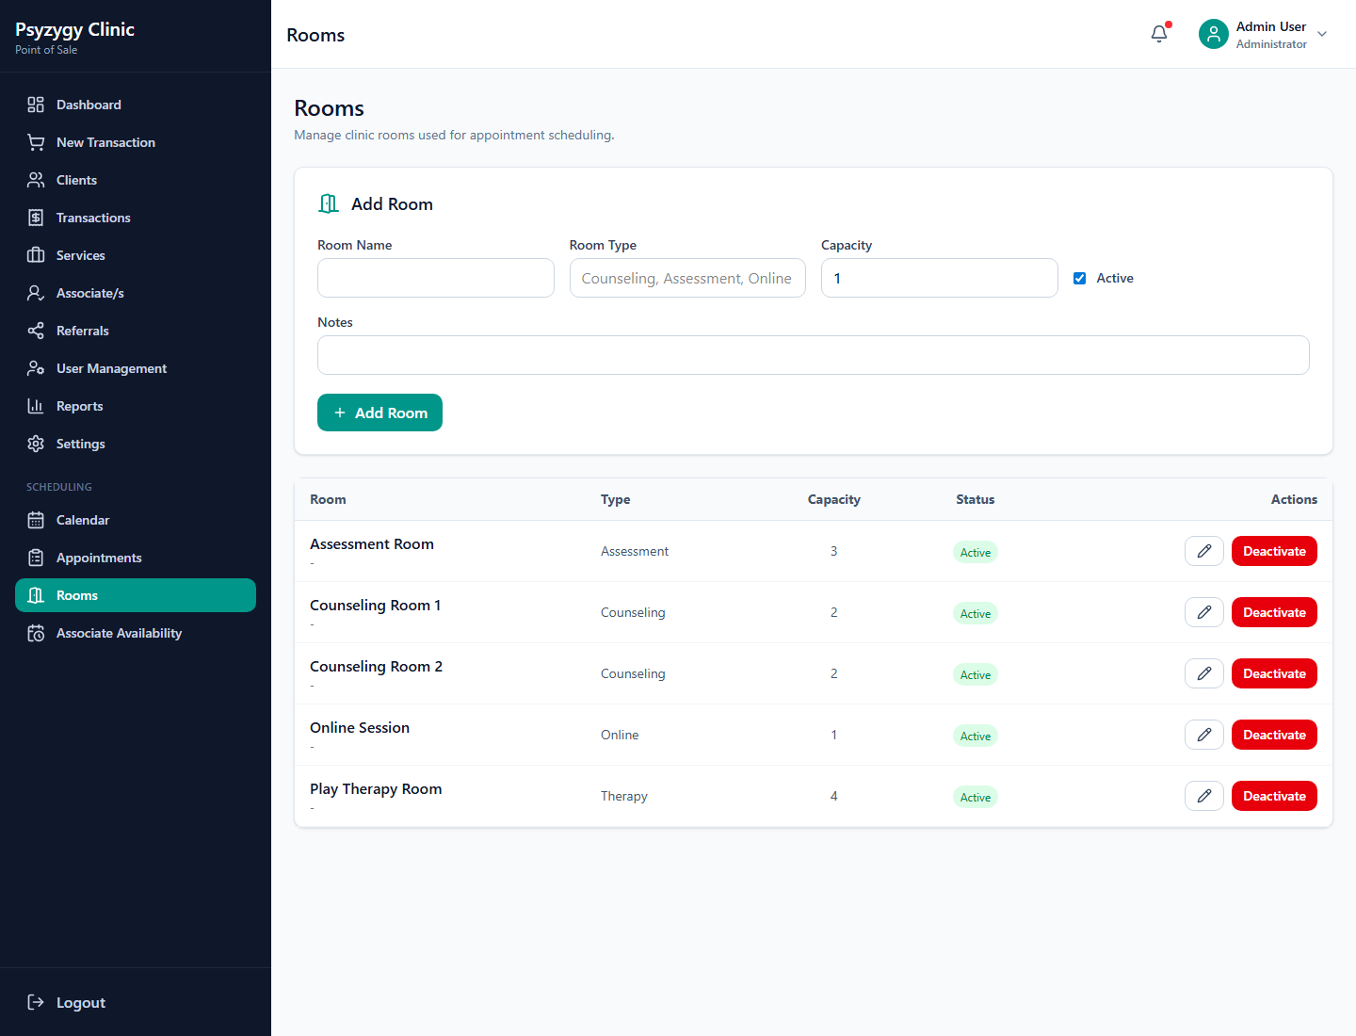
Rooms management
Use Rooms to manage clinic rooms and online session room entries.
Steps:
1. Go to Rooms.
2. Add or update the room name.
3. Set the room type.
4. Set capacity.
5. Mark the room active or inactive.
6. Add notes if needed.
7. Save the room record.
Notes:
? Inactive rooms should not be selected for new appointments.
? Use Online Session for online appointments when a physical room is not needed.

10. Associate Availability
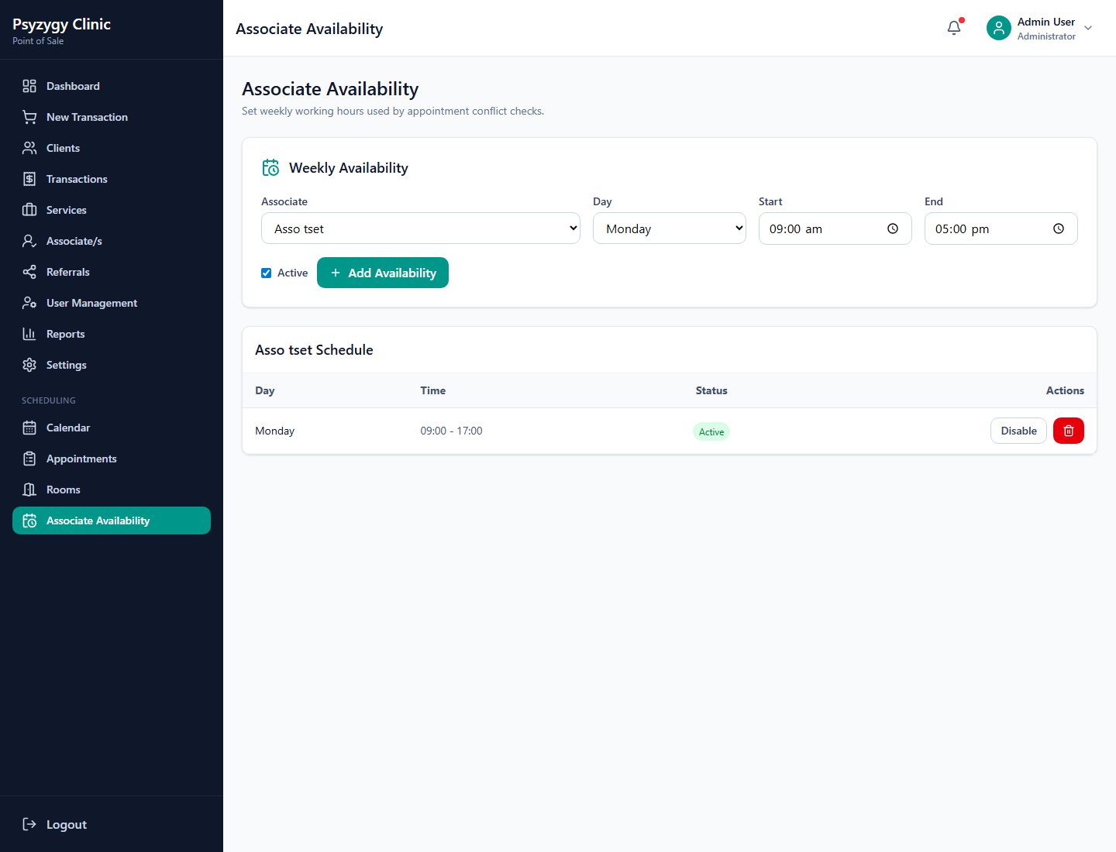
Associate availability
Use Associate Availability to define when each associate can be scheduled.
Steps:
1. Go to Associate Availability.
2. Select the associate.
3. Select the day of week.
4. Enter start time and end time.
5. Save the availability.
Scheduling uses this availability to recommend associates and warn staff when a selected time is outside availability.

11. Client Management
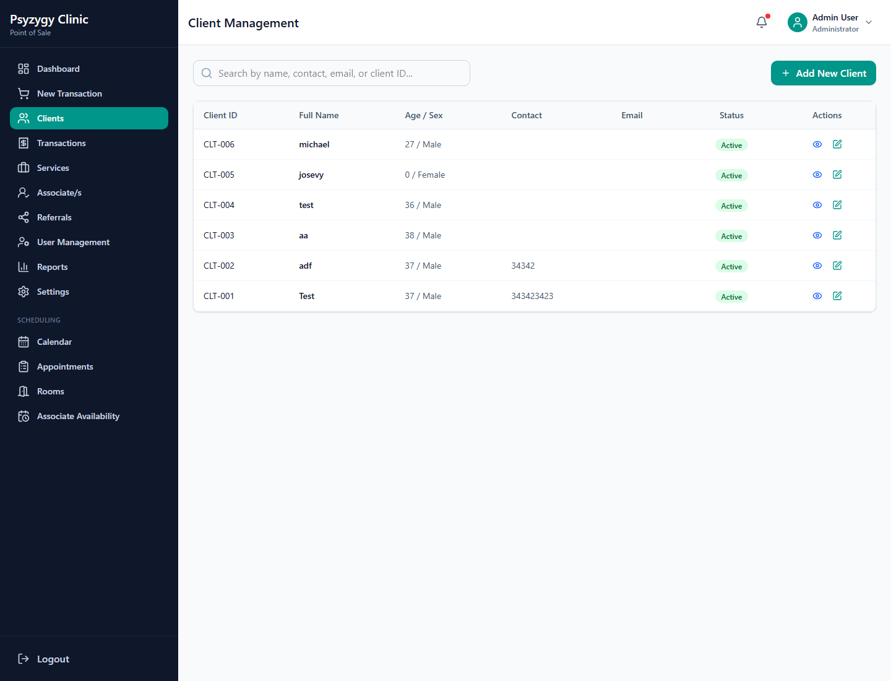
Clients page
Use Clients to manage client profiles.
Common tasks:
1. Add a new client.
2. Update contact information.
3. Review client demographics.
4. Confirm consent and privacy acknowledgement.
5. Search for existing clients before creating a duplicate record.
Best practice:
? Always search first before adding a new client.

12. Services Management
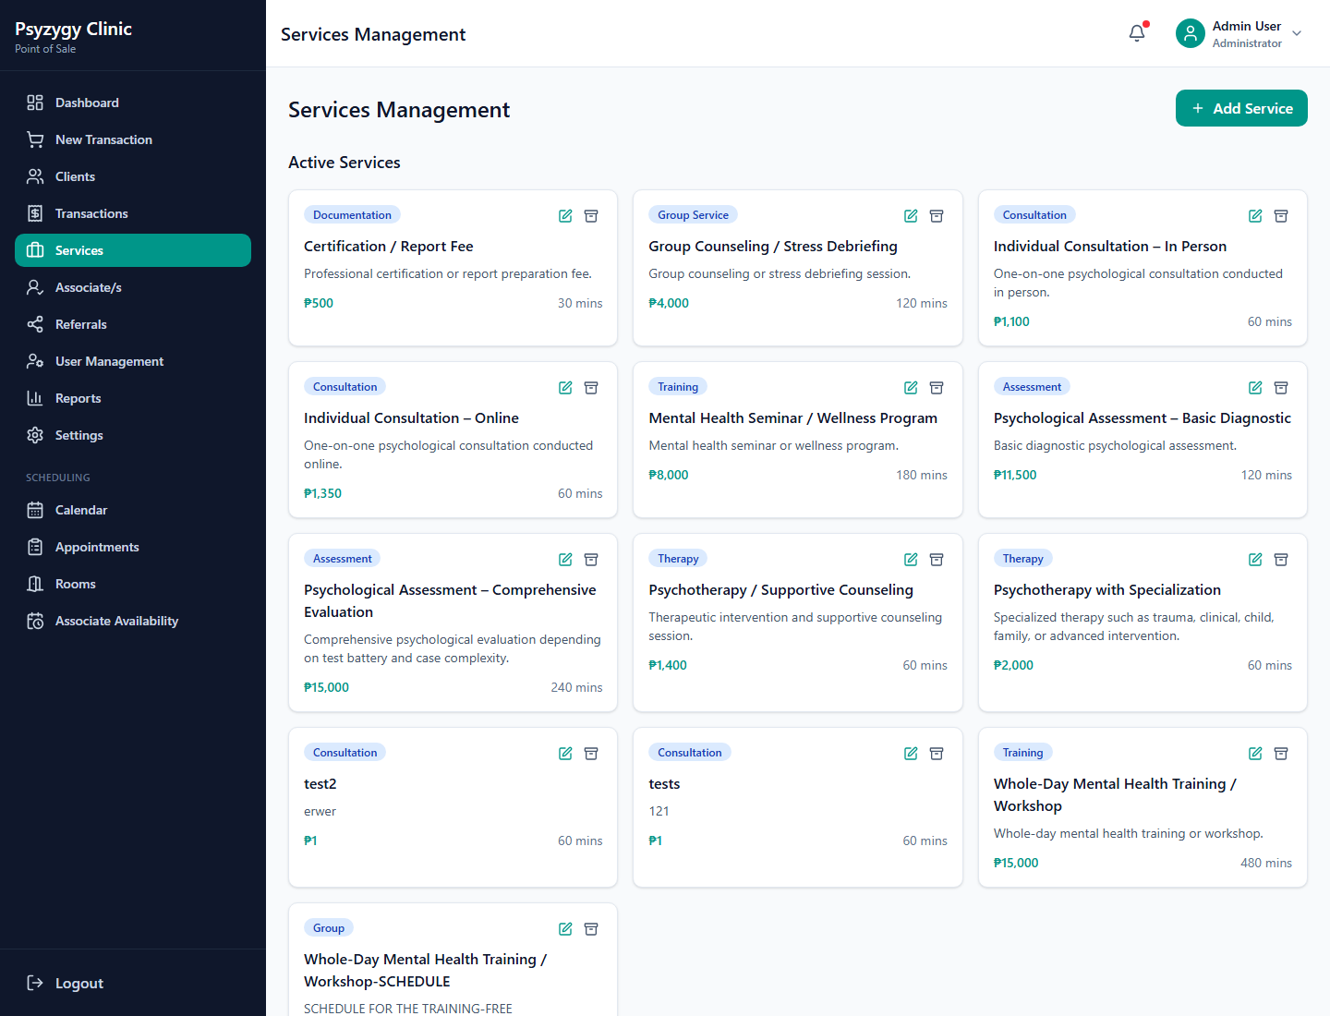
Services page
Use Services to manage clinic service offerings.
Common tasks:
1. Add a service.
2. Set category and description.
3. Set default price.
4. Set duration in minutes.
5. Mark services active or inactive.
Scheduling and POS both use active services.

13. Associate/s Management
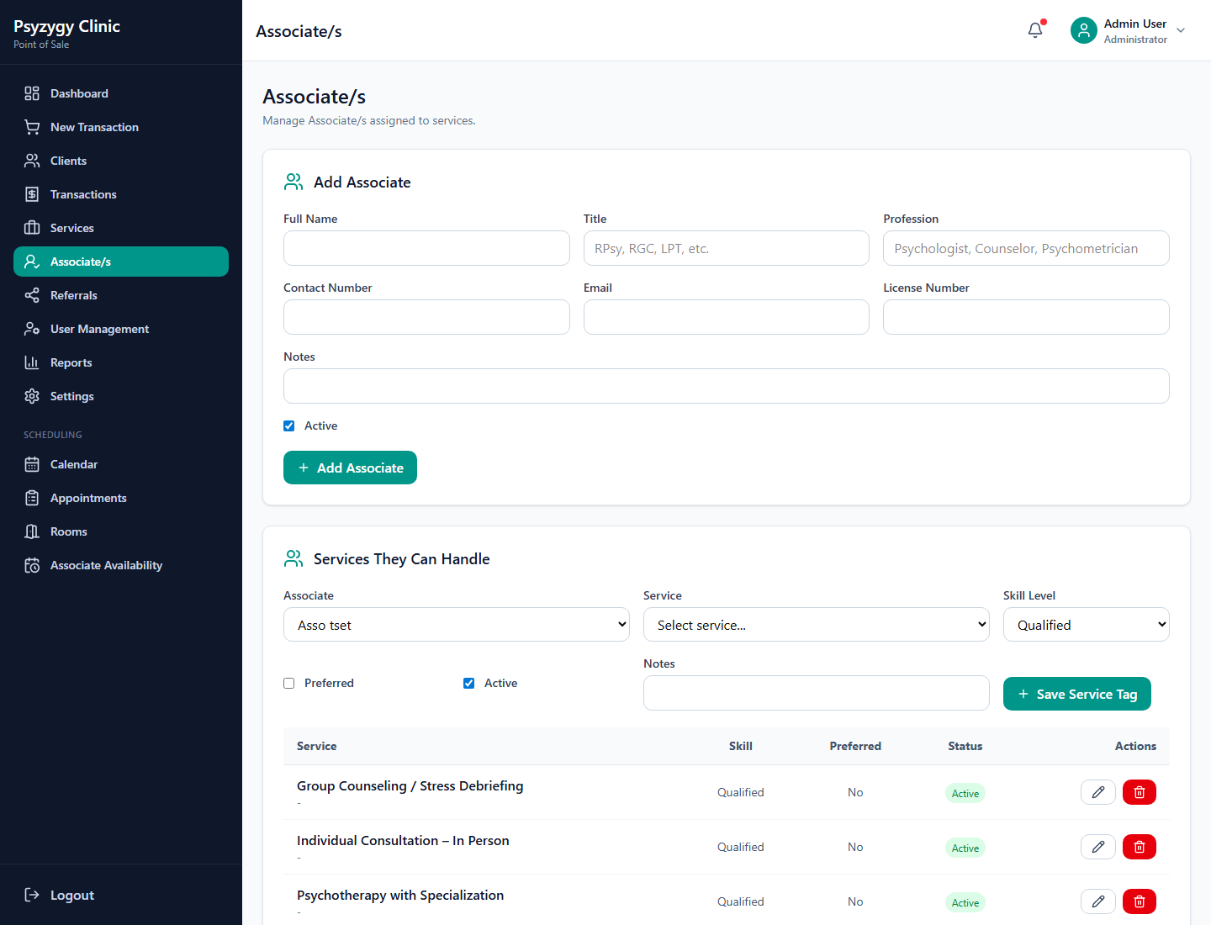
Associate/s page
Use Associate/s to manage clinic associates.
Common tasks:
1. Add or update associate details.
2. Record professional title and license number.
3. Mark associates active or inactive.
4. Assign services they can handle.
5. Set skill level as Qualified, Preferred, or Specialist.
These service tags help the scheduler recommend the best associate for an appointment.

14. Referrals
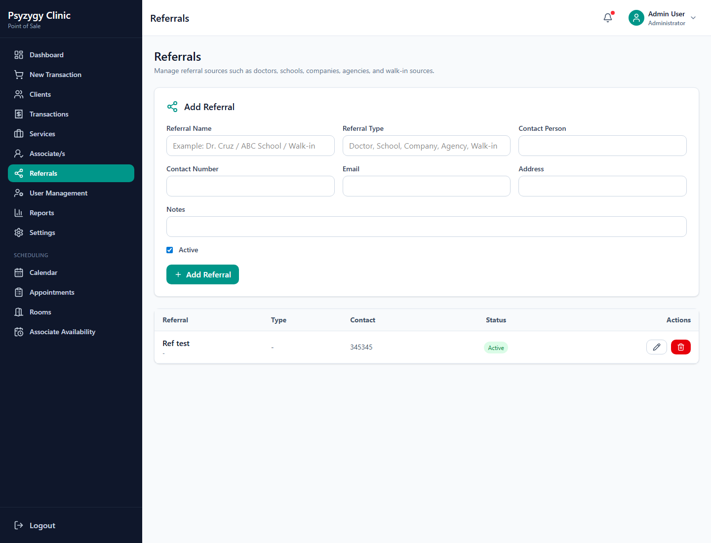
Referrals page
Use Referrals to manage referral sources.
Common tasks:
1. Add referral source name.
2. Set referral type.
3. Add contact person and contact details.
4. Mark referral source active or inactive.
5. Select referral sources during POS transactions and appointment scheduling.

15. Reports
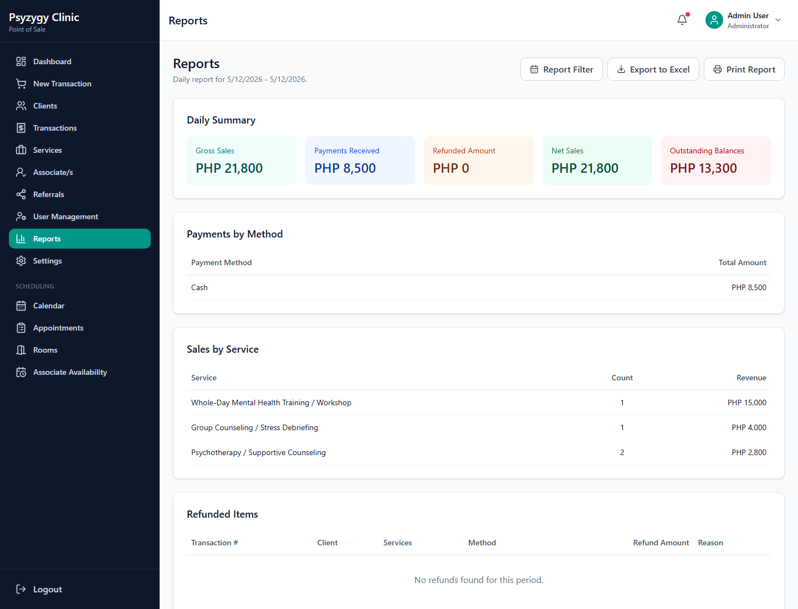
Reports page
Use Reports to review clinic sales and operational summaries.
Common tasks:
1. Select the report period.
2. Choose daily, weekly, monthly, or yearly filters.
3. Review paid, unpaid, refunded, and voided items.
4. Export or print reports when needed.
Reports should be reviewed before end-of-day reconciliation.

16. Settings
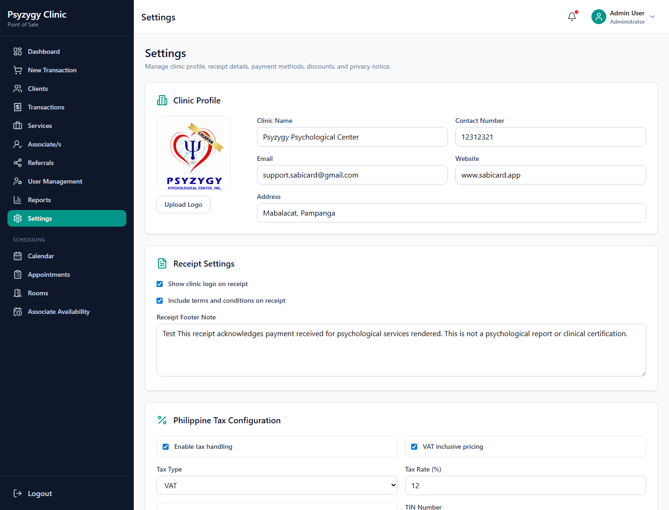
Settings page
Use Settings to manage clinic profile, receipt, privacy, payment, discount, and tax configuration.
Common settings:
1. Clinic name, address, contact number, and email.
2. Logo used on login and receipts.
3. Receipt footer.
4. Payment methods.
5. Discount types.
6. VAT or NON-VAT configuration.
7. TIN and BIR registration details.
8. Privacy notice.
Important:
? Changes to tax settings affect future transaction calculations and receipts.
? Confirm VAT/NON-VAT settings with clinic management before changing them.

17. Daily Front Desk Checklist
Start of day:
1. Log in with your own account.
2. Check the dashboard.
3. Review the appointment calendar.
4. Confirm rooms and associate availability for the day.
During operations:
1. Search for the client before creating a new client record.
2. Create appointments before payment when scheduling first.
3. Convert appointments to POS transactions when payment is ready.
4. Select the correct service, associate, referral, discount, and payment method.
5. Review VAT or NON-VAT display before saving.
6. Print receipts after payment is recorded.
End of day:
1. Review transactions.
2. Check unpaid and partial balances.
3. Review refunds and voided transactions.
4. Export or print reports if required.
5. Log out before leaving the workstation.

